To: Big Mountain Resort Management

From: Blaine Murphy, Data Scientist

Subject: ML Modeling of Lift Ticket Price

Date: 4/3/2021

# Summary

Big Mountain resort recently invested in a new chair lift that will increase annual operating costs by $1.54MM. Now there is a need to adjust the lift ticket price and management seeks a data driven solution to find the optimum price. Facilities data from ~300 resorts was gathered for analysis as well as state wide metrics on area and population. I created a Random Forest model which predicted a price of $94.22 This is an increase of $13.22 over the current ticket price, which is greater than mean absolute error of $10.39 in the prediction. Anticipating 350,000 annual customers averaging 5-day tickets, an increase of $0.88 is all that is needed to cover the operating expenses of the new chair lift. However, I recommend to increase the lift ticket price to $90.00 to both cover the cost of the new lift and increase revenue. The model shows that this price is supported by the national skiing market.

# Dataset and EDA

I received a csv file from the data manager with 330 rows, each one containing information for a single ski resort in the United States including Big Mountain Ski Resort. The dataset has 27 columns that include identifying information and 23 numeric columns with data on each resort’s facilities on offer. I cleaned the dataset by removing columns and rows with significant numbers of null values.

I created a new dataset grouping by state in order to understand the ski resort market in each state. I aggregated the data for total terrain parks, skiable acreage, days open, and night skiing acreage. Statewide population data was procured from Wikipedia and merged with the resort data by state to create a dataset to help better understand supply and demand.

Since most resorts have the same weekday and weekend ticket price and there are more known weekend prices, the adult weekend price will be the target for the model. At this point the data are in a clean format and ready for exploratory analysis.

I created a heatmap () a quick identifier of strong correlations to our target feature, the adult weekend lift ticket price. The features that immediately stood out with high correlation are vertical drop, number of fast quad lifts, number of runs, and acreage of snow making. Using my intuition of what could be important to customers I calculated and added ratios of features to the resort level data set.

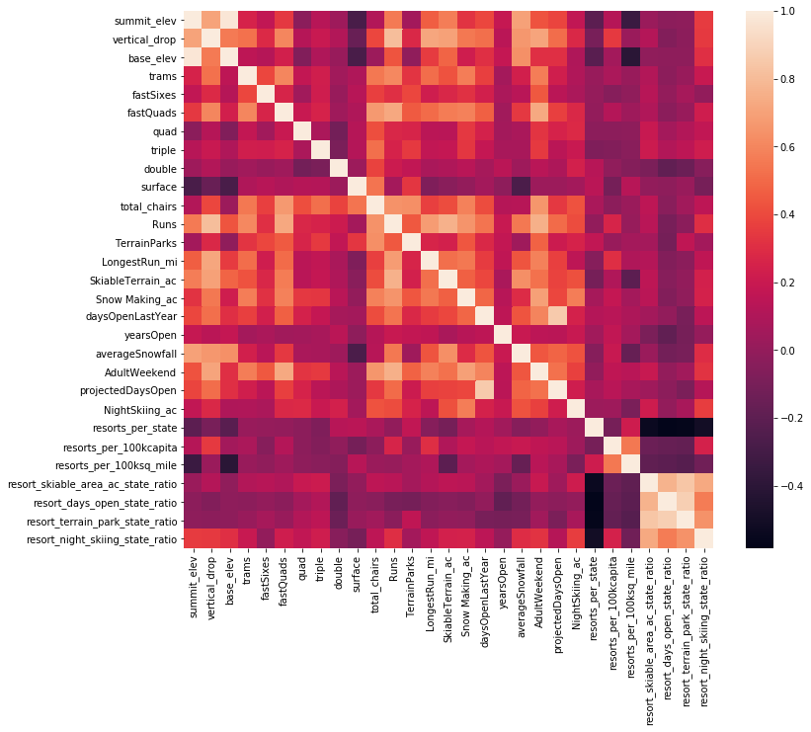

Figure : Heatmap of linear correlation between features of ski resort dataset.

# Preprocessing & Training

After cleaning and prepping the dataset, I created a random forest model to predict the ticket price. The model was created using cross validation in order to ensure predictive ability and with the number of estimators as a variable, so that I may choose based on which creates the most accurate prediction. The bar chart below shows the most import predictive features for the random forest model ().

Finally, I tested if additional data would significantly improve the model. This test showed no increase in cross validation scores over a training set size of 60, so I have plenty of data to use this model.

# Modeling

Currently Big Mountain resort charges $81 for an adult weekend lift ticket. Applying the model to Big Mountain finds a predicted ticket price of $94.22. The mean absolute error from this prediction is $10.39, which is less than the difference between predicted and current. The modeling suggests that Big Mountain resort can increase its lift ticket price based on market demand for its facilities.

The new chair lift at Big Mountain increases the annual operating expenses by $1,540,000. If we assume 350,000 customers for the next season with an average of 5-day lift tickets then increasing the price by $0.88 from the current price will cover the operating cost of the new lift. An increase of $0.88 amounts to a ~1% increase over the current ticket price, well below the model predicted increase of $13. Increasing the ticket price by the model predicted value of $13 increases revenue by $22,750,000, assuming the same number of customers.

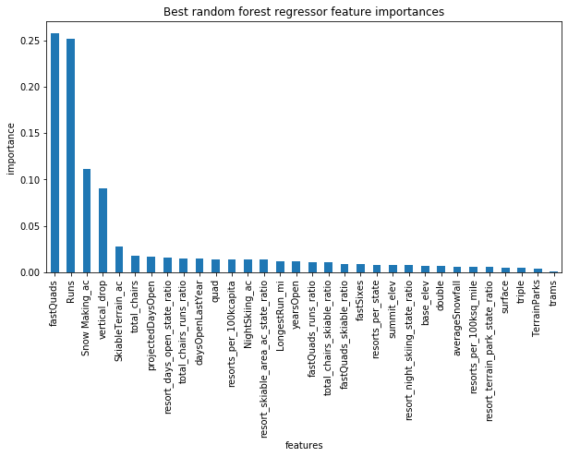

Figure : A bar chart showing the most important predictive features for the random forest model.

I can test the ticket price supported by the market by changing certain features for Big Mountain and passing it back through the model. Of the 4 proposed investment scenarios, 2 & 4 are the only scenarios that support a ticket price increase. Scenario 1, which proposes closing some number of the least used runs on the mountain, supports a price decrease. The modeled decreases changes in a stepwise fashion as a function of the number of runs. In order to know if this is a good financial decision, we would have to understand the cost savings involved with closing some of these less popular runs.

# Further Work

This model is effective at predicting ticket price according to the national market of ski resorts. Various investment strategies can be passed to the model to understand what ticket price will be supported by the market. The model will be deployed in such a manner that anyone can quickly and easily run complex scenarios to determine what ticket price is supported by the investment. It will also be easily updated to include any new data on other ski resorts.

To improve the predictive capacity of the model in the future, customer data should be included. Knowing where customers are coming from and how many are season pass holders will be key in choosing a new lift ticket price.